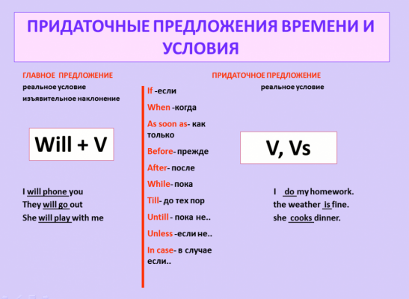

Условные предложения первого типа (First conditional) используются, когда мы говорим о реальных событиях будущего времени. То есть, если выполнится условие, то действие произойдет в будущем.
Также вместо if могут использоваться: When - когда While – в то время как, пока, в течении Before – до After – после As soon as – как только Until (till) – до, до этого момента
IF + PRESENT SIMPLE, + FUTURE SIMPLE

Ex. 1. Put the verb in the brackets in the correct tense to form the First Conditional.
If Maria (go) abroad, she (go) to England or America. She (visit) London if she (go) to England. If she (stay) in London, she (spend) much money. She (not be able) to stay for long if she (spend) all her money. If her holiday (be) very short, she (not practice) her English. It (be) a pity if she (not try) to speak English.
Ex. 2. Put the verbs in the brackets into the Present Indefinite or the Future Indefinite Tense
- If Peter __________ (come) to my place, we__________ (go) to play in the yard.
- If Peter__________ (not come) to my place, I __________ (watch) TV.
- If Frank’s parents__________ (have) their holidays in summer, they __________ (go) to the seaside.
- If they __________ (have) their holidays in winter, they __________ (stay) at home.
- If the fog _______ (thicken), Harold _______ (put up) the tent for the night.
- When I _______ (finish) my work, I_______ (go) to the cinema.

ART IN OUR LIFE
Art plays an important role in the life of a man. It helps the people`s understanding of their culture. Art allows people to talk about emotionally meaningful experiences.
I think that art has many functions and it’s hard to overestimate the role of art in one’s life. Art has great influence on our souls, feelings, forms our moral values. Art forms our outlook and enriches our inner world. Art makes us think of the sense of life, how people must live, what is ideal of beauty, what is love the eternal questions. Art helps us to understand people who lived hundred years ago and to learn the history of the humankind. Art helps people to understand outside world and each other. Art develops our good qualities. Art has a great educational significance. Art brings people up - makes them more humane and kind.
It is natural that the first thing that comes to my mind at the mention of the word ‘art’ is museums. A museum is a stock of the world’s masterpieces, it is the place, where you can enrich knowledge, you can look at the achievements of mankind, you can satisfy your aesthetic taste. Museums give the possibility to be always in touch with the past and every time discover something new for yourself. Besides, museums play an important role in the life of any nation. A museum is just the right place to find out lots of interesting things about history, traditions and habits of different peoples. One may find in museums papers, photos, books, scripts, works of art, personal things of famous people etc. All this helps us to understand historical events, scientific discoveries, character and deeds of well-known personalities better. I think museums somehow effect the formation of personality, his outlook. Every educated person is sure to understand the great significance of museums in our life; you may go to your favourite museum, relax there with your body and soul and acquire inner harmony and balance.
But to my mind everywhere you go art is evident. Parks often use sculptures to add interest and to inform people. Posters on walls give information and motivation. Music plays on the radio to keep your energy levels up. Without even realizing it we find ourselves immersed in the power of art most of the time!
Art is everywhere, influencing us on a daily basis, whether we realize it or not. With the art that we are surrounded by, whether it’s a painting, music or even videos it can have a huge impact on our mood and emotions. All kinds of art can affect our mood in a positive way, making us feel happier, calmer, or even inspired to do something.
Выполнить письменно упражнения и устно прочитать текст.

