1 задание выполнить письменно, остальные выполнить устно
“At the door of school” by Bogdanov-Belski

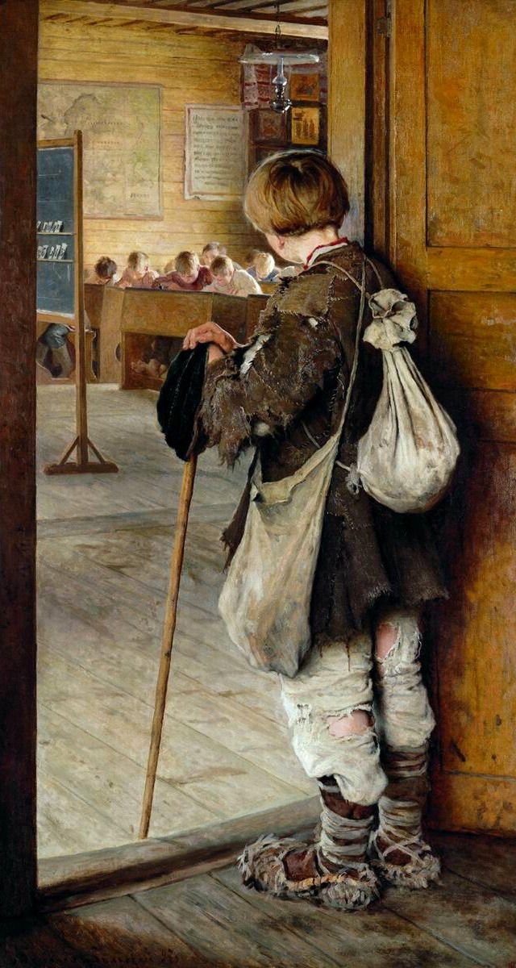
Ex.1. Look at the painting by Bogdanov-Belski “At the door of school” and answer the following questions
- This is a picture of the school, isn’t it?
- Is it a picture of a country school or a city school? How do you know?
- What can we see on the foreground?
- Who is standing at the door of the classroom?
- The boy is very poor, isn’t he? How do you know?
- How is the boy dressed?
- What is the boy leaning on?
- The boy is very tired, isn’t he?
- What has the boy got on the back?
- Why can’t the boy learn at school?
- Why must the boy do instead of going to school? Why must he work?
- Does the boy want to learn at school? What makes you think that he wants to learn?
- He would like to sit at the desk with the other children, wouldn’t he?
- What can we see in the background?
- What are the pupils doing?
- Why do you think one pupil is looking at the boy standing at the door? Do you think he is poor boy’s friend?
- What can we see on the walls of the classroom?
- Can you see a lamp hanging from the ceiling? Is it an electric lamp or kerosene lamp?
- The picture shows the hard life of peasants in old times, doesn’t it?

Ex. 2. Read the description of the picture
At the door of the school
This is a picture of a country school
In the foreground, we see a peasant boy. He is standing at the door of the classroom. They boy is very poor. He is dressed in ragged clothes. He is leaning on the stick. Evidently, he is very tired. The boy had two bags: one on his back and the other on his side.
The boy cannot learn at school because he is poor. He must work to help his family. But he wants to learn very much, that’s why he has come to school. He is looking at the pupils. He would like to sit at the desk, too!
In the background, we see part of the classroom. We see part of the blackboard on the left and some desks on the right. The pupils writing something. One pupil is looking at the boy. Perhaps he is his friend.
One the wall we can see a map and some pictures. There is a kerosene lamp hanging from the ceiling. They picture shows the hard life of peasants in old times.

Ex. 3. Describe the picture close to text, or learn the text by heart.

